Project Documentation

Inventory-management-frontend

# Introduction

## Project Title: Store Manager: Keep track of inventory

* + **Team ID:NM2025TMID39938**
  + **Team Leader: Abinaya.K(abi06311520@gmail.com)**
  + **Team Members:**
    - Keerthika-Keerthikaapkeerthika004@gmail.com
    - Jagadeeshwari-jagadeeshwari.m1121@gmail.com
    - Joshna-anbalaganjoshna@gmail.com

# Project Overview

* + **Purpose:** SB Works connects clients and freelancers through project postings, bidding, and real-time communication.

## Features:

* + - Project posting and bidding
    - Secure chat system
    - Feedback and review system
    - Admin control panel

# Architecture

* + **Frontend:** React.js with Bootstrap and Material UI
  + **Backend:** Node.js and Express.js managing server logic and API endpoints
  + **Database:** MongoDB stores user data, project information, applications, and chat messages

# Setup Instructions

## Prerequisites:

* + - Node.js
    - MongoDB
    - Git
    - React.js
    - Express.js **–** Mongoose **–** Visual Studio Code

## Installation Steps:

# Clone the repository git clone

# Install client dependencies cd client npm install

# Install server dependencies cd

../server npm install

# Folder Structure

SB-Works/

|-- client/ # React frontend

| components/ L pages/

| server/ # Node.js backend

| routes/

| models/

| controllers/

# Running the Application

## Frontend:

cd client npm start

•**Backend:**

Cd server

npm start

* + **Access:** Visit [http://localhost:3000](http://localhost:3000/)

# API Documentation

## User:

* + - /api/user/register
    - /api/user/login

## Projct:

* + **Chats:**
* /api/projects/create
* /api/projects/:id

• **Applications:** /api/apply

* /api/chat/send
* /api/chat/:userId

# Authentication

* + JWT-based authentication for secure login
  + Middleware protects private routes

# User Interface

* + Landing Page
  + Freelancer Dashboard
  + Admin Panel
  + Project Details Page

# Testing

* + Manual testing during milestones
  + Tools: Postman, Chrome Dev Tools

1. **Screenshots or Demo**

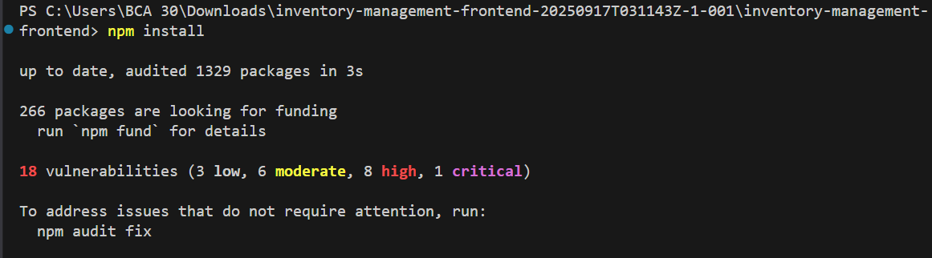

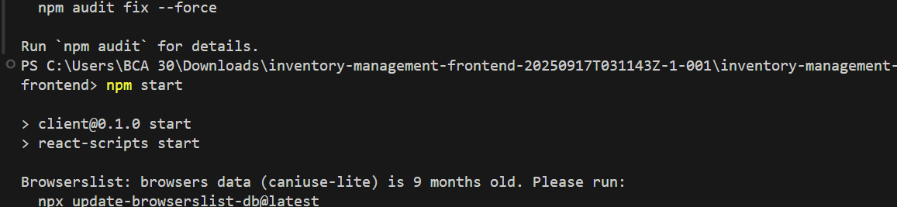

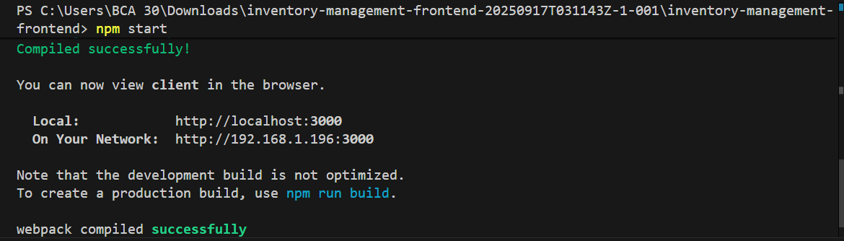

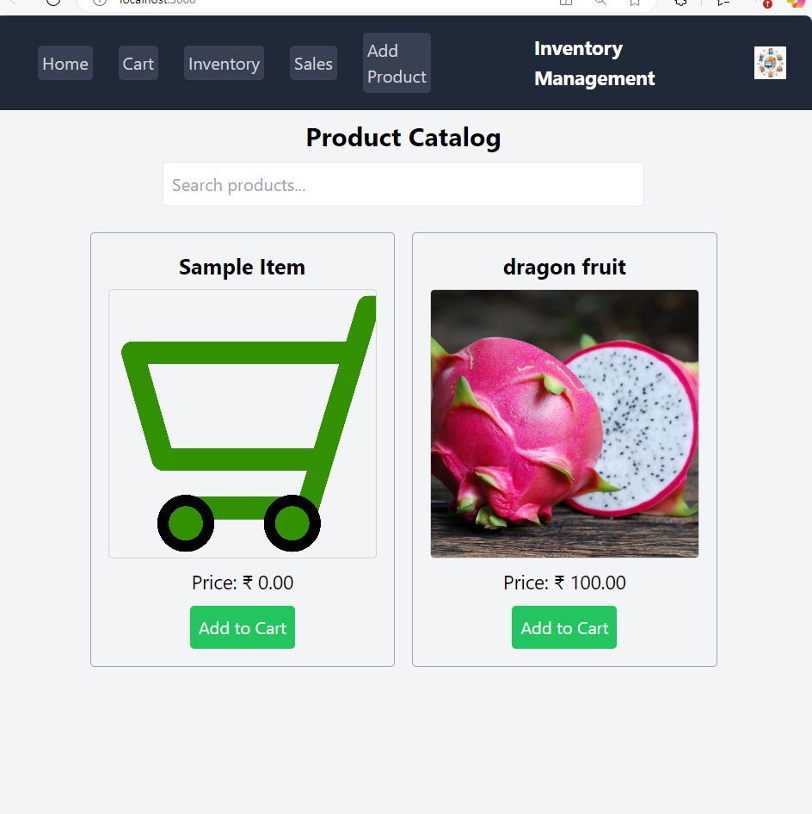

1. **Known Issues:** Nil
2. **Future Enhancements**

• **Mobile Application Support** – Develop Android and iOS apps for wider accessibility.

• **AI-Powered Matching** – Use machine learning to suggest the best freelancer for each project.

• **Payment Gateway Integration** – Enable secure online payments and escrow services.

• **Video & Voice Calls** – Add real-time communication features beyond chat.

• **Advanced Analytics** – Provide project performance, freelancer success rates, and client satisfaction dashboards.

• **Internationalization (i18n)** – Support multiple languages and currencies.

• **Freelancer Skill Verification** – Automated tests or certifications for freelancers.

• **Project Recommendation Engine** – Personalized project suggestions based on user activity.

• **Automated Dispute Resolution** – Smart system to resolve conflicts between clients and freelancers.

• **Cloud Deployment** – Migrate to scalable cloud infrastructure (AWS, Azure, or GCP) for better performance.